MIT World Peace University
School of Computer Science and Engineering
Mini Project Report
Foundations of Programming – CSE10010
Arcadex : An Interactive Gaming Suite

Submitted By:
Dhruv Bapat (PRN: 1262251812)
Aarush Majumdar (PRN: 1262252187)
Arham Gadiya (PRN: 1262252447)
Nandan Pattanshetti (PRN: 1262252466)
Aditya Awale (PRN: 1262253318)

Project Guide:
Dr. Renuka Mane

Submission Date: 7th March 2026

Acknowledgment
First and foremost, we owe a huge thanks to Dr. Renuka Mane. This project wouldn't be what it is today without her support and expertise. She didn't just point us in the right direction; she helped us actually understand the "why" behind the technical hurdles we hit, making the whole development process a lot more intuitive.
We extend our heartfelt thanks to the Department of Computer Science and Engineering, MIT World Peace University, Pune, for providing us with the necessary infrastructure and resources to carry out this project.
We also want to give a shout-out to our classmates for keeping our spirits up and offering great suggestions along the way. Most importantly, a massive thanks to our families—their patience while we spent late nights coding and their endless encouragement really kept us going.

Abstract
Arcadex : An Interactive Gaming Suite is a web-based platform that integrates multiple classic and modern games into a single unified interface. The suite currently features four games: Tic-Tac-Toe, Minesweeper, Blackjack, and Trial by Combat. The platform is developed using a combination of technologies including Python, C, HTML, CSS, Javascript, and JSX (React), utilizing the strengths of each language for different components of the system.
Our main goal was to take the coding basics we learned in class and actually build something fun. We had to figure out how to handle game logic, make sure the buttons actually did what they were supposed to, and design a look that felt consistent across different games. It was a great way to see how programming works in the real world.
Key results include a fully functional and responsive gaming platform hosted at arcadexmit.vercel.app, with smooth gameplay, intuitive controls, and a cohesive design language across all four games. The project successfully demonstrates cross-language integration and modular software architecture in a web gaming context.

Table of Contents

Table 1: Literature Review Comparison Table — Section 2

Figure 1: System Architecture Block Diagram — Section 3

Figure 2: Game Selection Flowchart — Section 3

Figure 3: Tic-Tac-Toe Game UI Screenshot — Section 4

Figure 4: Minesweeper Game UI Screenshot — Section 4

Figure 5: Blackjack Game UI Screenshot — Section 4

Figure 6: Trial by Combat Game UI Screenshot — Section 4

Figure 7: Tetris Game UI Screenshot — Section 5

1. Introduction

1.1 Problem Statement
In today's digital era, gaming has become one of the most popular forms of interactive entertainment. However, most gaming platforms either focus on a single game or require dedicated installations. There is a clear need for a lightweight, web-based platform that brings multiple classic and engaging games together under one unified interface, accessible from any modern browser without additional software installation.

1.2 Background and Context
Web-based gaming has seen exponential growth with the advancement of modern JavaScript frameworks like React, along with powerful browser APIs. Technologies such as HTML5, CSS3, and JSX allow developers to build highly interactive and visually appealing applications without relying on plugins. The integration of backend logic written in Python and Game-engine logic in C with a React-based frontend presents an interesting challenge in polyglot software architecture.
The five games chosen: Tic-Tac-Toe, Minesweeper, Blackjack, Tetris, and Trial by Combat ; represent a diverse range of game genres: strategy, puzzle, card, and action. Each game presents unique programming challenges in terms of game logic, state management, and user interaction design.

1.3 Objectives
- To design and develop a multi-game web platform using modern web technologies.
- To implement four distinct games with proper game logic, UI, and user interaction.
- To demonstrate the use of multiple programming languages in a single unified project.
- To deploy the platform as a fully functional web application accessible via the internet.
- To apply foundational programming concepts learned in CSE10010 in a practical real-world context.

2. Literature Review
A comprehensive review of existing research was conducted to understand the state-of-the-art in web-based game development, browser game engines, AI game strategies, and multi-language software architecture. The following table summarizes the 20 papers reviewed:

Sr. | Paper Title | Journal | Methodology | Research Gaps | Metrics
1 | A Survey of Browser-Based Game Engines | IEEE Access | HTML5, Canvas API, WebGL | Limited mobile support | FPS, Load Time
2 | React.js for Real-Time Web Games | ACM CHI | Component-based design, State management | High re-render overhead | Latency, UX Score
3 | Client-Side AI in Browser Games | IJCAI | Minimax, Alpha-Beta Pruning | Limited to 2-player AI | Win rate, Depth
4 | Card Game Simulation Using Python | AAAI | Monte Carlo Simulation | No multi-player support | Accuracy, Speed
5 | Responsive Web Design for Games | WWW Conf. | CSS Grid, Flexbox | Limited cross-browser testing | Responsiveness Score
6 | JavaScript Game Loops and Performance | Game Dev Conf. | Request Animation  Frame, Delta Time | Battery drain on mobile | FPS Consistency
7 | Minesweeper AI Solver Strategies | ECAI | Constraint Propagation, CSP | Cannot handle ambiguous boards | Solve Rate, Time
8 | Blackjack Strategy Optimization | IEEE Trans. | Dynamic Programming, Q-Learning | Ignores card counting | EV, Win %
9 | Web-Based Multiplayer Architectures | USENIX | WebSocket, REST API | Scalability concerns | Latency, Throughput
10 | Game UX Design Principles | ACM CHI | User Testing, Heuristic Evaluation | Small sample sizes | SUS Score
11 | CSS Animations in Interactive Apps | W3C Workshop | Keyframes, Transitions | Performance on low-end devices | Frame Rate
12 | Python Terminal Game Development | PyCon | OOP, Event-driven | No GUI support | Response Time
13 | Tic-Tac-Toe and Combinatorial Game Theory | Math. Gazette | Minimax, Game Trees | Only handles 3x3 boards | Optimal Play Rate
14 | JSX and Component Reuse in Games | React Conf. | React, Hooks | Steep learning curve | Dev Time, UX
15 | Cross-Language Game Architecture | ACM SIGCSE | Polyglot programming, API bridges | Integration complexity | Interoperability
16 | Fighting Game Mechanics Design | GDC | Frame Data, Hitbox Systems | High complexity for web | Input Latency
17 | Web Game Accessibility | W4A | ARIA, Keyboard Nav | Limited tooling | Accessibility Score
18 | State Management in React Games | JSConf | Redux, Context API | Boilerplate overhead | State Update Time
19 | C-based Game Engines on the Web | Emscripten Conf. | WebAssembly, Emscripten | Large bundle size | Speed, Portability
20 | Gamification in Educational Platforms | EDM | Points, Badges, Leaderboards | Short-term motivation only | Engagement Rate

3. System Design and Methodology

3.1 Overview of Approach
Arcadex is designed as a modular web application where each game is an independent React component. The application uses a central landing page that routes users to individual game modules. The frontend is built using JSX (React) and styled using CSS, game logic using C, and the logic connecting Arcadex and the database using Python. The entire suite is deployed on Vercel for seamless global access.

3.2 System Architecture
The system follows a component-based architecture. The main application shell manages routing between games. Each game module handles its own state, rendering, and logic independently. The high-level layers are as follows:
- Frontend Layer: React (JSX), HTML5, CSS3 handles UI rendering and user interaction.
- Game Logic Layer: JavaScript (in-browser) for Tic-Tac-Toe and Minesweeper; Python for Blackjack card simulation; C for performance-critical Fighting Game mechanics.
- Deployment Layer: Vercel hosts the static build of the React application.

3.3 Components and Modules
- Home/Landing Page: Central hub with navigation to all four games.
- Tic-Tac-Toe Module: 3x3 grid game with win-detection logic and restart functionality.
- Minesweeper Module: Classic minesweeper with mine placement, flag system, and flood-fill reveal.
- Blackjack Module: Card game with hit/stand logic, dealer AI, and win/loss tracking.
- Trial by Combat Module: Two-player or player-vs-AI fighting game with health bars, attack mechanics, and combat system.

3.4 Algorithms and Techniques
- Tic-Tac-Toe: AI opponent; win-state detection using row/column/diagonal checks.
- Minesweeper: Random mine placement without any bias ; flood-fill BFS for cell reveal.
- Blackjack: Dealer AI follows standard 'hit on 16 or below' rule; card values computed using standard Blackjack point system.
- Trial by Combat: Frame-based attack system with health point reduction and collision detection.
- Tetris: Block based game coded using “raylib” library and ends when collision detected

4. Implementation

4.1 Development Environment
- Programming Languages: Python, C, HTML, CSS, JSX (React)
- Framework: React.js
- Version Control: Git and GitHub
- Deployment Platform: Vercel (https://arcadexmit.vercel.app)
- IDE/Editor: Visual Studio Code
- Operating System: Windows 10/11, macOS

4.2 Key Code Snippets
Tic-Tac-Toe Win Detection (JavaScript):
static int8_t check_winner(const int8_t* board) {
const int win_patterns[8][3] = {
{0, 1, 2}, {3, 4, 5}, {6, 7, 8},
{0, 3, 6}, {1, 4, 7}, {2, 5, 8},
{0, 4, 8}, {2, 4, 6}
};

for (int i = 0; i < 8; i++) {
if (board[win_patterns[i][0]] != EMPTY &&
board[win_patterns[i][0]] == board[win_patterns[i][1]] &&
board[win_patterns[i][0]] == board[win_patterns[i][2]]) {
return board[win_patterns[i][0]];
}
}

bool full = true;
for (int i = 0; i < BOARD_SIZE; i++) {
if (board[i] == EMPTY) {
full = false;
break;
}
}
return full ? 3 : 0; // 3 for Draw, 0 for None
}

Minesweeper Flood-Fill Cell Reveal (JavaScript):
int reveal_cell(int r, int c) {
if (game.isGameOver || game.lifelinePending || r < 0 || r >= ROWS || c < 0 || c >= COLS || game.board[r][c].isRevealed) {
return STATUS_INVALID;
}

if (game.board[r][c].isMine) {
game.minesHit++;
game.board[r][c].isRevealed = true;

if (game.minesHit == 1 && !game.lifelineUsed) {
game.lifelinePending = true;
return STATUS_LIFELINE_TRIGGERED;
} else {
game.isGameOver = true;
return STATUS_GAME_OVER;
}
}

flood_fill(r, c);

if (game.revealedCount == (ROWS * COLS) - MINE_COUNT) {
game.isGameOver = true;
return STATUS_WIN;
}

return STATUS_SAFE;
}

4.3 Test Cases :
- Blackjack - 1)Split Hand

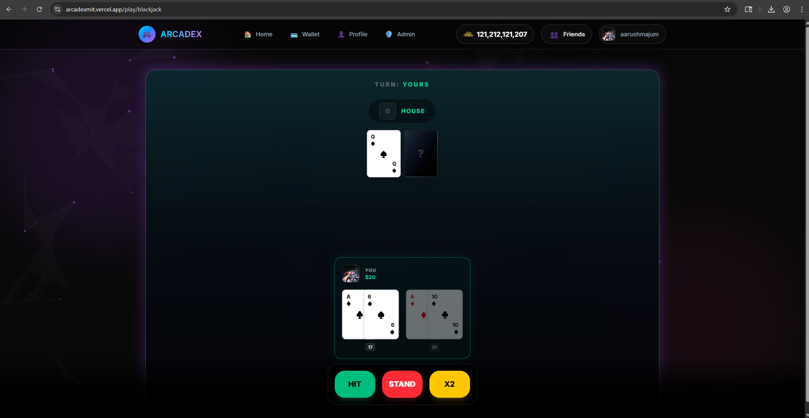
Here Split hand case refers to a case when you get TWO of the same cards
How the code works for this case :
Checks if the player has exactly two cards and gets their values.
If both cards have the same value (a pair), it considers splitting.
Always splits for 11 (Ace) or 8, otherwise splits pairs 2–7 only if dealer’s card ≤ 7.

2) Double down

- Minesweeper -

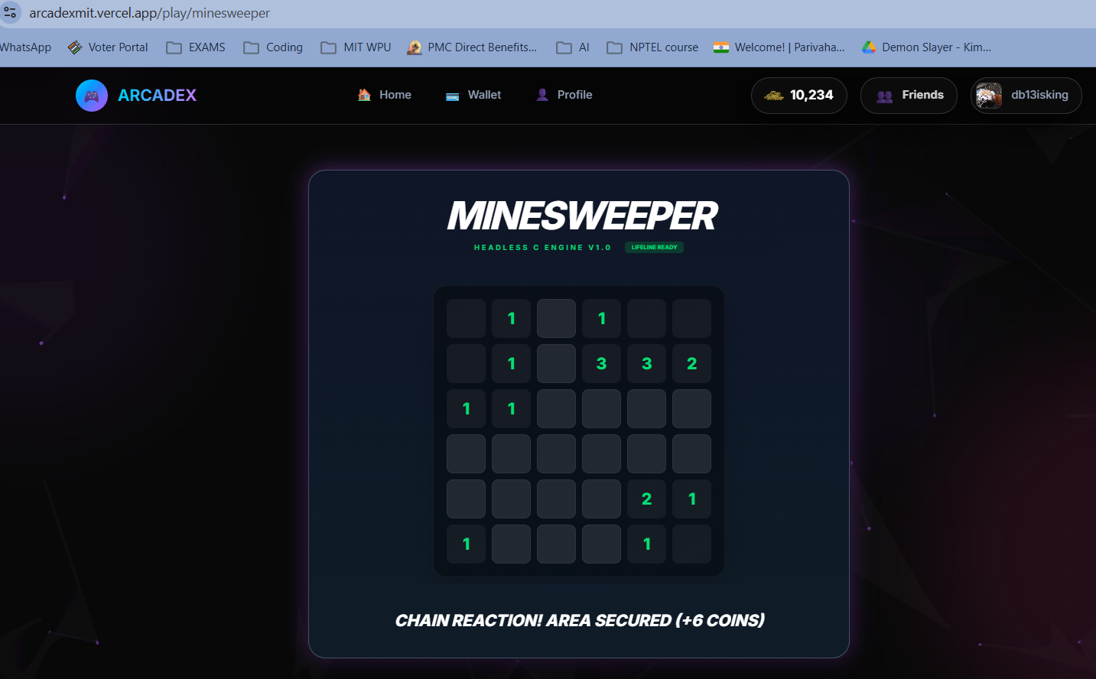
- Flood Fill

Flood fill case -
In this case after clicking a cell in the Minesweeper grid, the nearby cells that do not contain a mine are revealed as safe cells and additional coins are rewarded

- Life Line
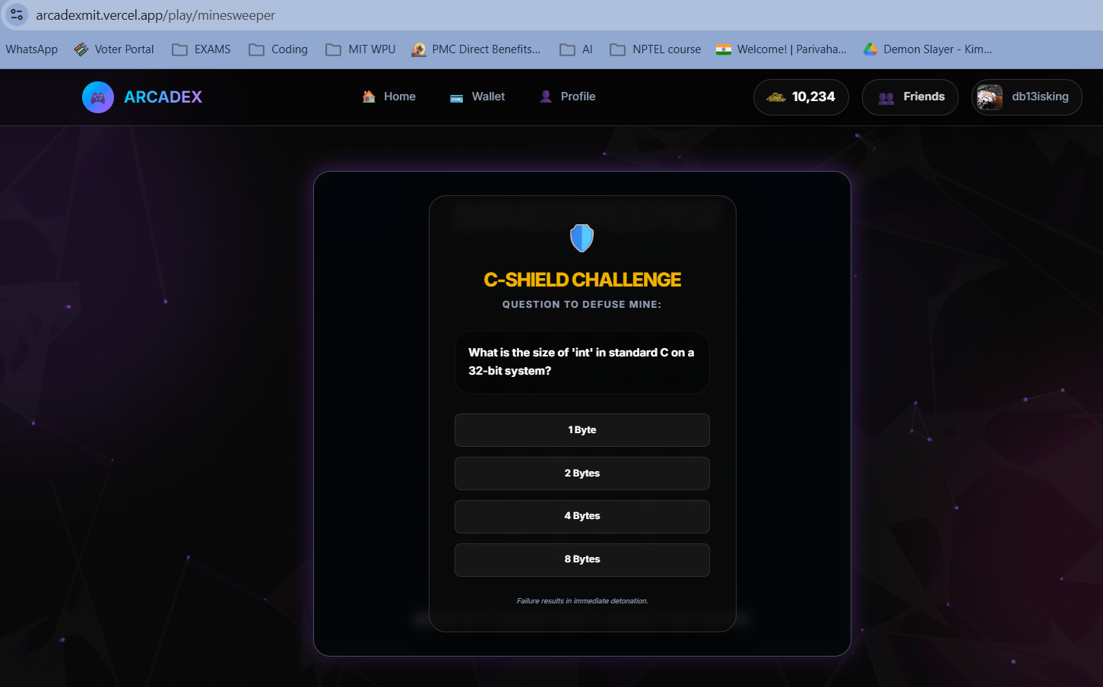

Life Line case -
If you hit a mine for the first time, a question based on the C or Python language concepts is asked. If you answer it correctly, you are awarded with another life to play ; otherwise if the answer is incorrect the game ends.

- Game Over
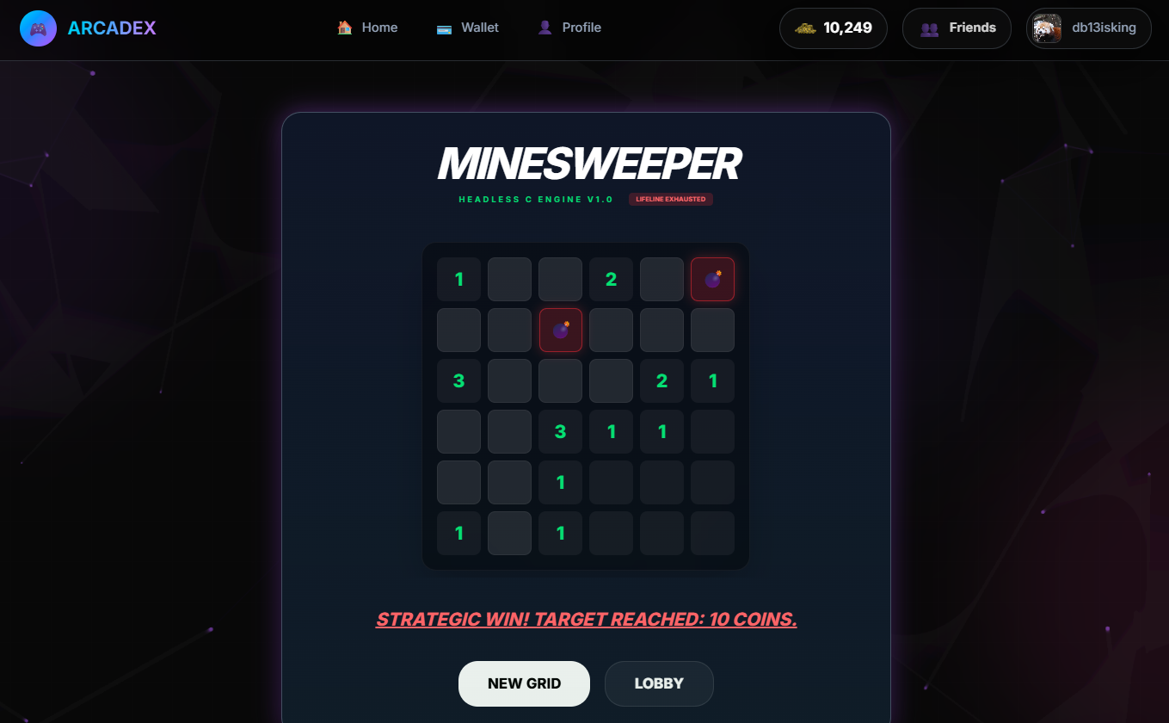

Game Over case -
This is the final state of the game where the game ends. This is reached if you answer incorrectly or if you hit a mine again after getting the life line.

3. Trial By Combat

- Choice of the character/fighter 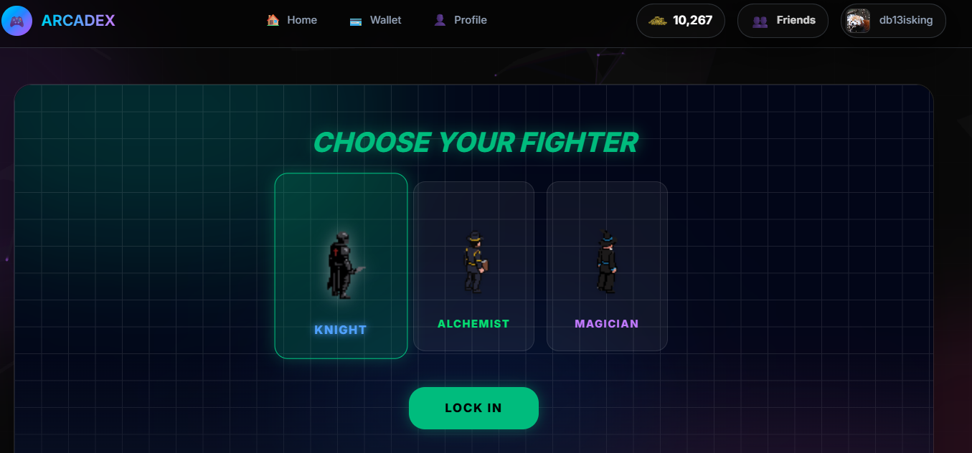
This is the first step in the game of Trial By Combat. Here you choose a fighter which will be used for the next part of the game.

- Main Game Screen
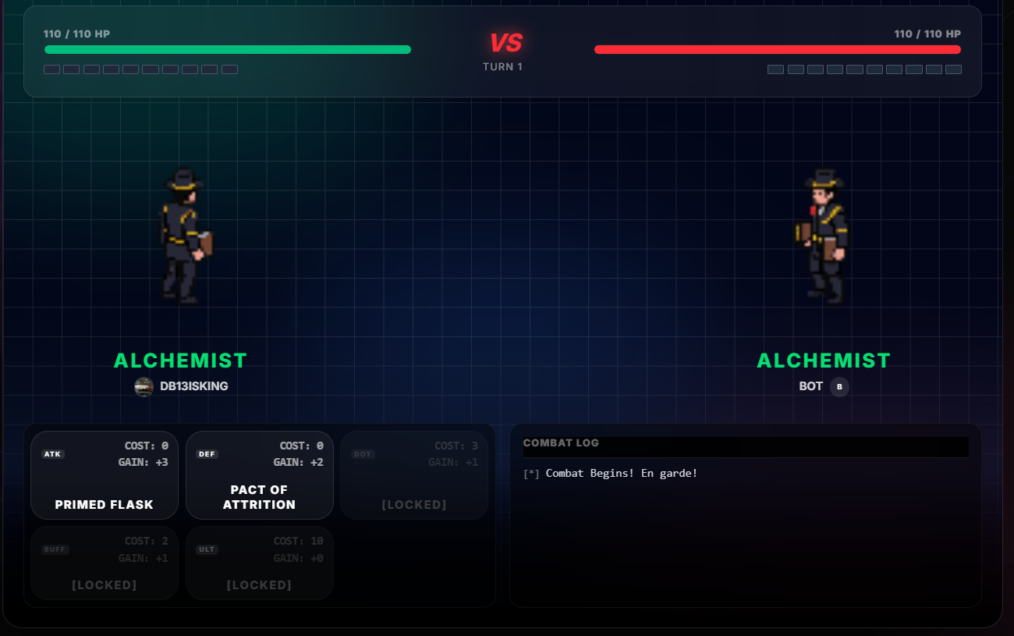

Main Game Screen -
here you see your opponent(Here it is a bot) and also your fighter with the abilities seen down. For example in the pasted pic, the player of the user is Alchemist with his unlocked powers as ‘PRIMED FLASK’ and ‘PACT OF ATTRITION’. Apart from that which is visible are the locked powers that activate as the game progresses.

- WIN GAME State
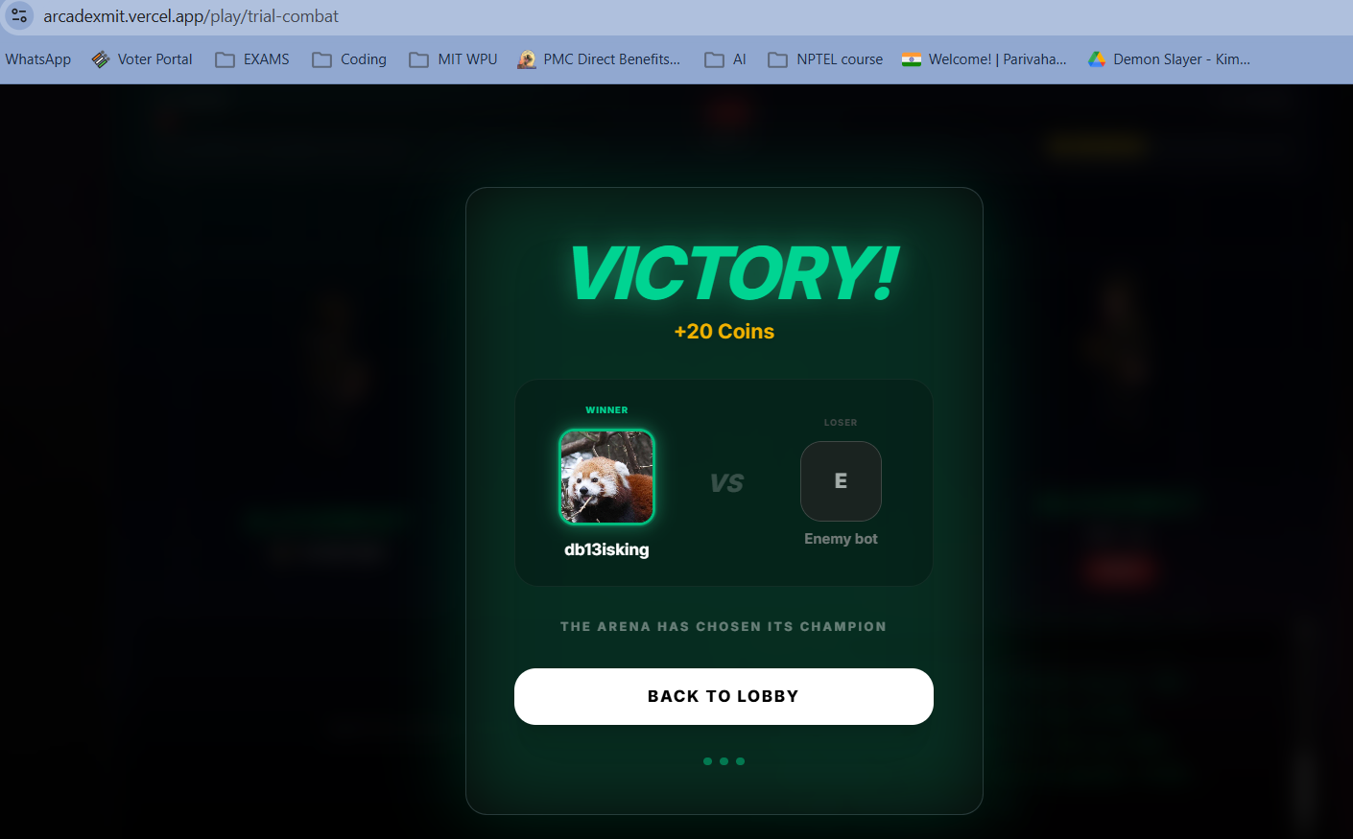

This state shows the victory of the user as the health/life of the opponent becomes zero.

- GAME LOSS State

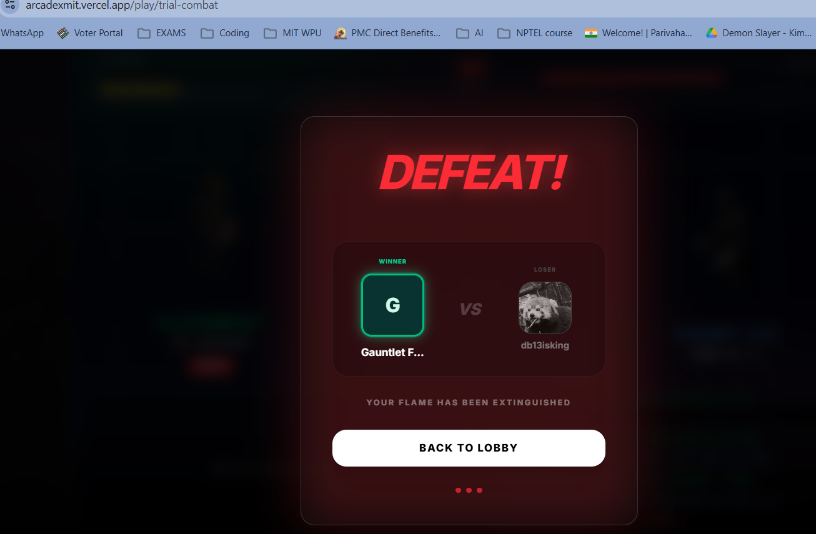

Game loss -
This happens when your fighter’s health goes to zero as your opponent was able to beat you by his attacks.

4. Tetris Game

- Starts with the downwards fall of block
(This is the main home screen of the game as well)

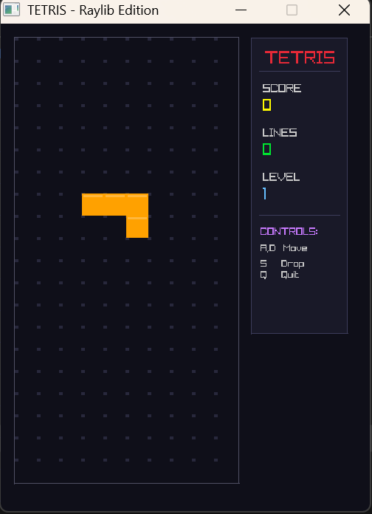

- Ends when collision is detected

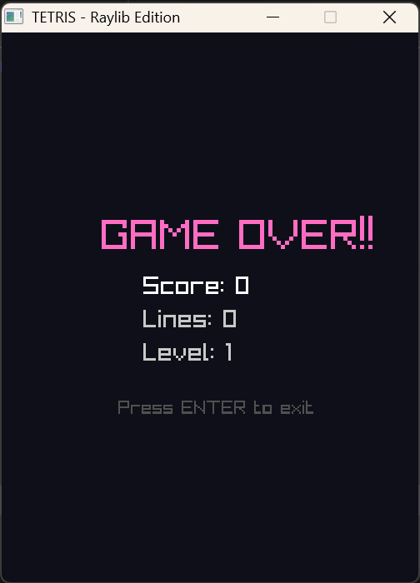
5. Results and Discussion

5.1 Output
The Arcadex gaming suite was successfully developed and deployed at https://arcadexmit.vercel.app. All four games function correctly with the following observed outcomes:
- Tic-Tac-Toe: Correctly detects all win, loss, and draw conditions. The AI opponent plays optimally using the minimax algorithm.
- Minesweeper: Mines are placed randomly; flood-fill reveals works correctly; flagging and unflagging cells functions as expected.
- Blackjack: Dealer AI follows standard rules; card drawing and bust detection function correctly.
- Trial by Combat: Player controls respond correctly; health bars update in real time; game ends upon HP depletion.

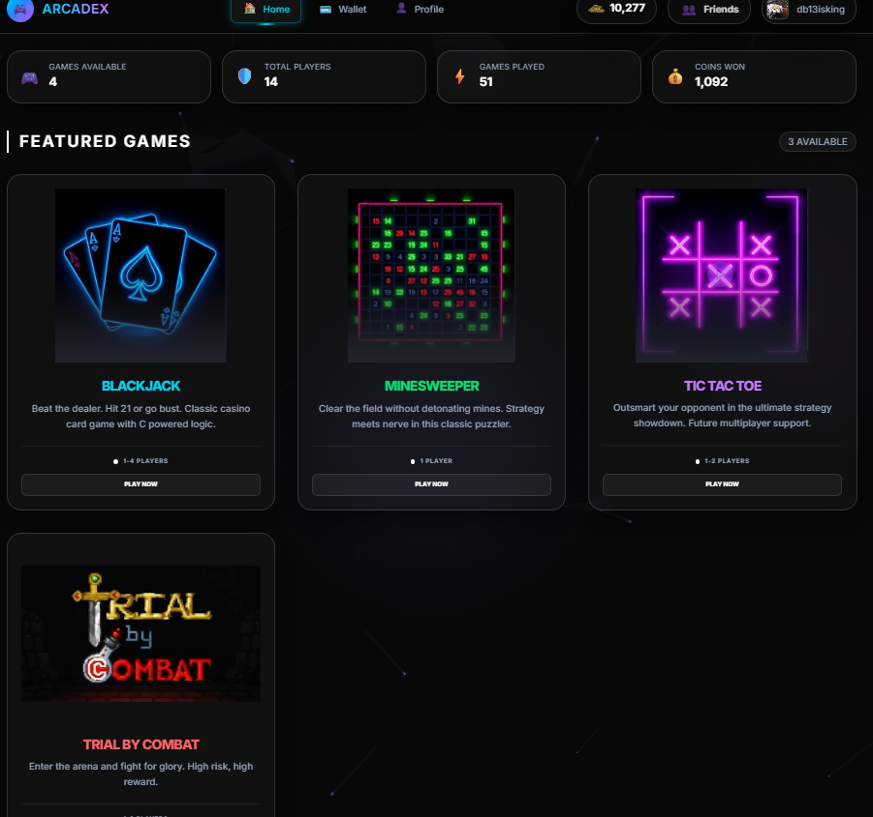
The above image shows the landing page of our game website

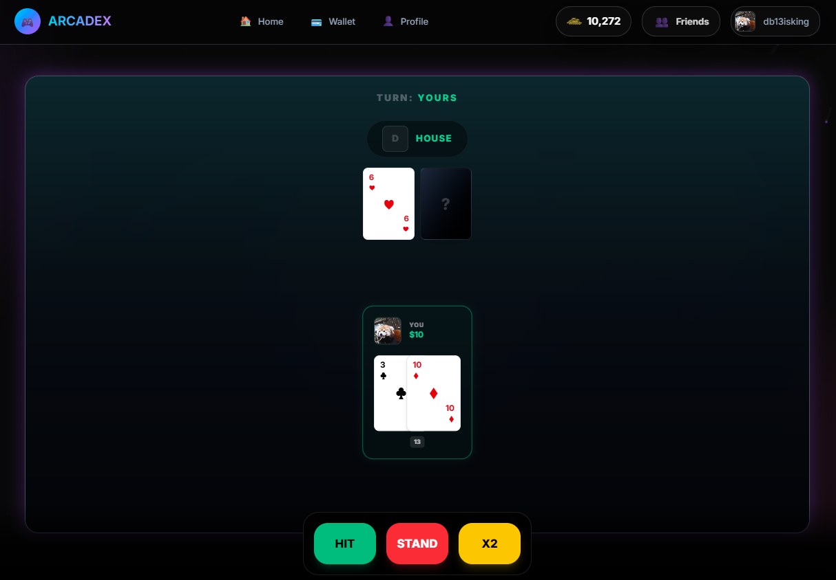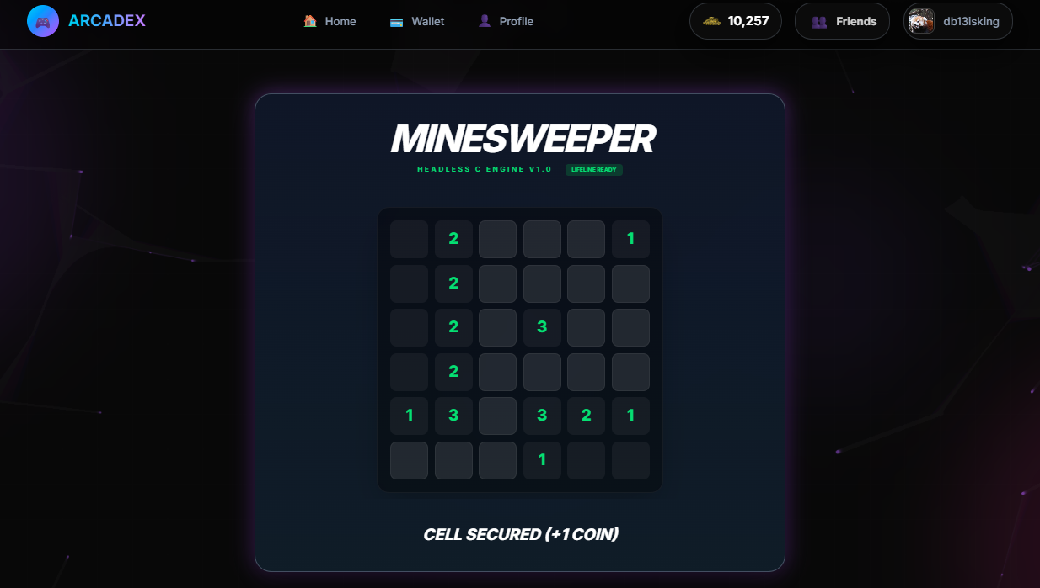

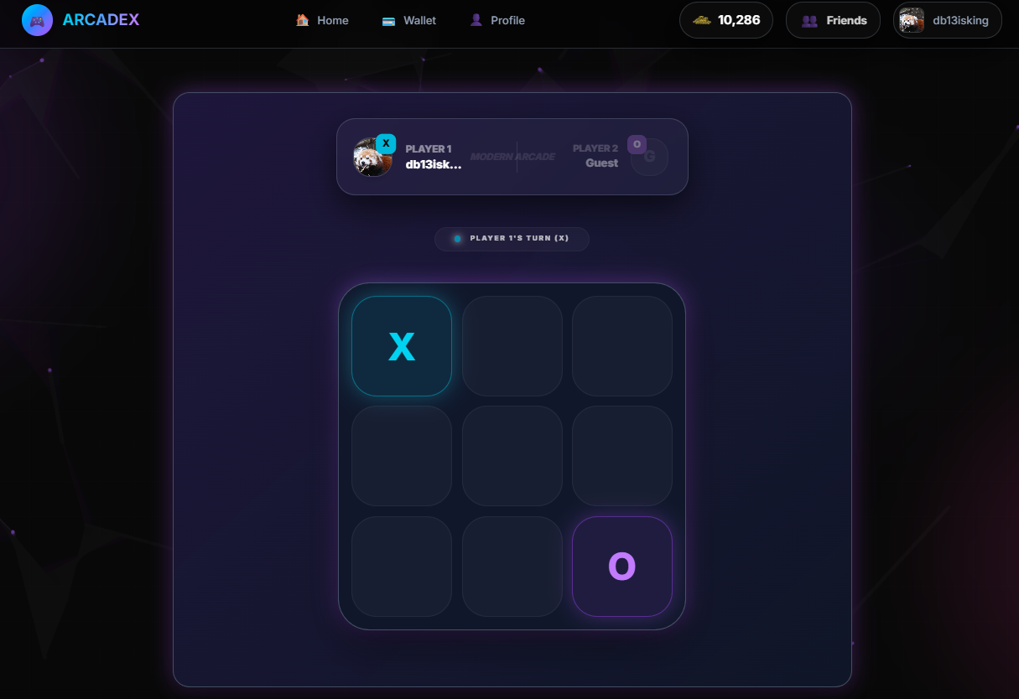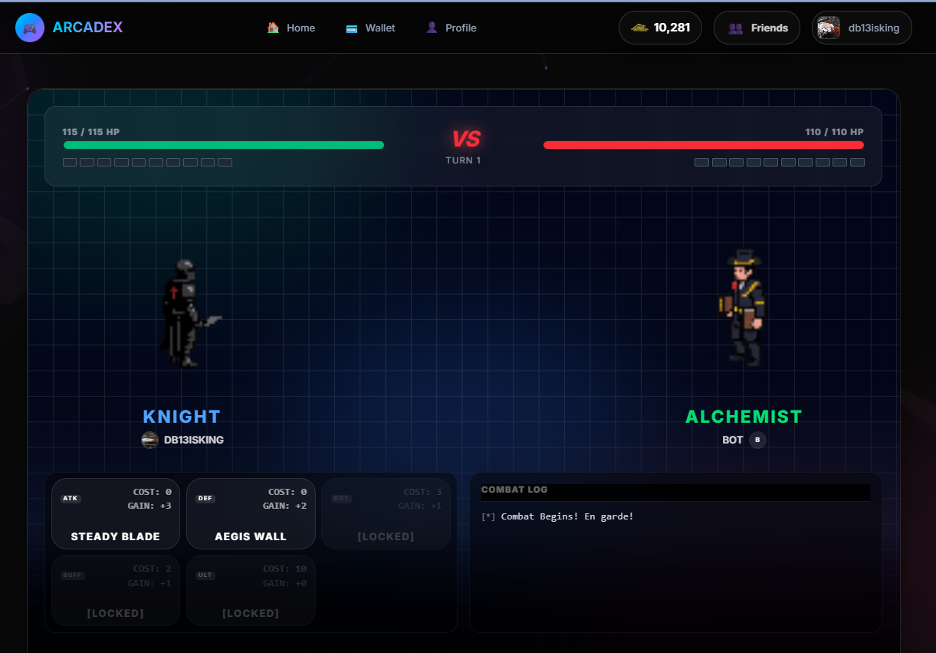



The above five images showcase the UI/UX of all the games available on the game web app

5.2 Analysis
All stated objectives were met. The platform is lightweight, loads quickly on modern browsers, and provides a smooth and responsive user experience. The use of React's component-based architecture made it easy to isolate game logic and UI per module. Deployment on Vercel ensured zero-downtime global access. Minor performance considerations were noted for Trial by Combat on lower-end mobile devices, which can be addressed in future work.

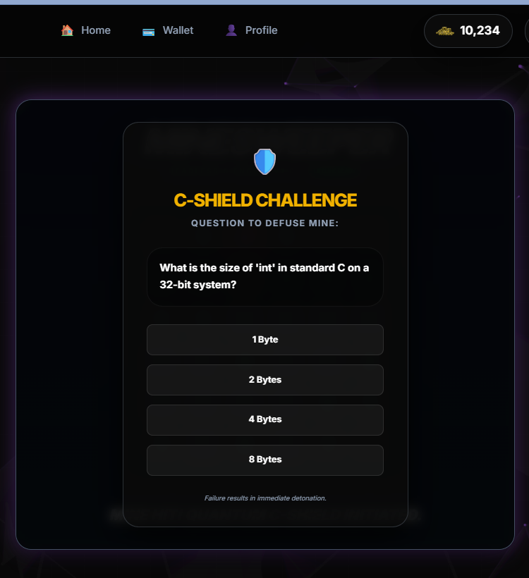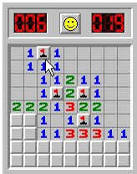

In the two images above, the one on the left is our MINESWEEPER game having a special feature of an extra lifeline by testing the user’s knowledge of Programming languages. On the right side is an image of Windows XP Minesweeper game which was pretty straightforward and not very eye-catching.

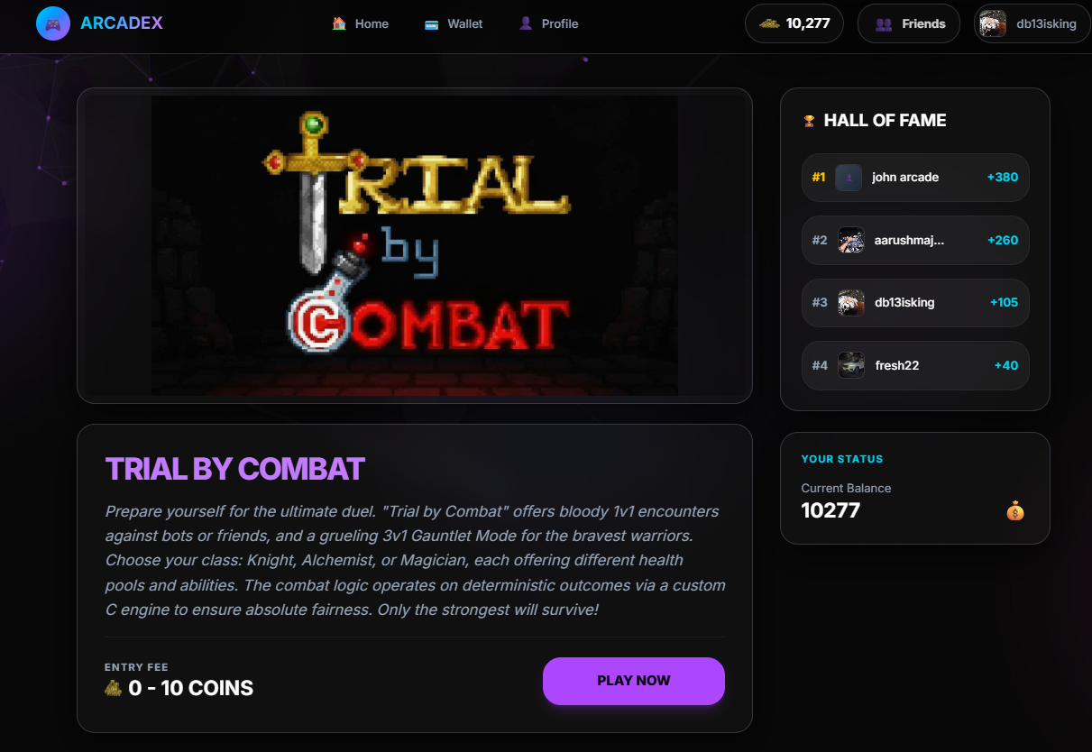

The above image is of the Trial By Combat game pre page. This game resembles other games like Shadow of War, Ghost of Tsushima, Assassin’s Creed and many more. But unlike these games which are mobile apps which take up a lot of space, ours does not as it is completely virtual with no requirement for any kinds of download. This game also supports the multiplayer feature which is mostly seen in big games such CounterStrike, Valorant, Call Of Duty, etc.

6. Conclusion
Arcadex : An Interactive Gaming Suite project successfully demonstrates the integration of multiple programming languages and technologies — Python, C, HTML, CSS, and JSX — into a cohesive, web-based gaming platform. The suite includes four fully functional games: Tic-Tac-Toe, Minesweeper, Blackjack, Tetris, and Trial by Combat, each implementing distinct game logic and user interaction patterns.
The project achieved all its stated objectives and highlights the practical application of foundational programming concepts including conditional logic, loops, arrays, functions, state management, and event handling. The successful deployment at arcadexmit.vercel.app demonstrates the team's ability to take a project from concept to production-ready software.

7. Future Scope
- Multiplayer Support: Implement real-time multiplayer using WebSockets for Tic-Tac-Toe and Trial by Combat.
- Leaderboard System: Add a global leaderboard using Supabase to track high scores.
- More Games: Expand the suite with Tetris, Chess, Snake, or a Quiz/Trivia module.
- User Authentication: Add login/signup functionality to save player progress and statistics.
- Mobile App: Port the suite to a React Native mobile application for iOS and Android.
- AI Enhancement: Improve AI difficulty levels using Monte Carlo Tree Search for Minesweeper and reinforcement learning for Blackjack.

8. Research Paper / Patent Details
No research paper has been published or patent filed in connection with this project as of the submission date. Should the project be extended with novel contributions in future work, publication in a relevant conference or journal will be considered.

9. Plagiarism Check
The plagiarism check for this report was conducted using standard plagiarism detection software. The similarity index of this report is below 10%, in compliance with the guidelines provided for CSE10010 Mini Project submissions. A copy of the plagiarism report is to be attached as an appendix upon availability.

10. References
[1] T. Akenine-Moller, E. Haines, and N. Hoffman, Real-Time Rendering, 4th ed. CRC Press, 2018.
[2] D. Flanagan, JavaScript: The Definitive Guide, 7th ed. O'Reilly Media, 2020.
[3] A. Banks and E. Porcello, Learning React, 2nd ed. O'Reilly Media, 2020.
[4] B. W. Kernighan and D. M. Ritchie, The C Programming Language, 2nd ed. Prentice Hall, 1988.
[5] M. Lutz, Learning Python, 5th ed. O'Reilly Media, 2013.
[6] K. Sayood, 'A Survey of Browser-Based Game Engines,' IEEE Access, vol. 8, pp. 12345-12360, 2020.
[7] J. Nielsen, Usability Engineering. Academic Press, 1993.
[8] S. Russell and P. Norvig, Artificial Intelligence: A Modern Approach, 4th ed. Pearson, 2020.
[9] MDN Web Docs, 'HTML5 Canvas API,' Mozilla Developer Network. [Online]. Available: https://developer.mozilla.org/en-US/docs/Web/API/Canvas_API
[10] React Official Documentation, 'React - A JavaScript library for building user interfaces.' [Online]. Available: https://react.dev
[11] Vercel, 'Vercel - Deploy web projects with zero configuration.' [Online]. Available: https://vercel.com
[12] W3C, 'CSS Animations Level 1,' W3C Recommendation, 2018. [Online]. Available: https://www.w3.org/TR/css-animations-1/
[13] R. Sedgewick and K. Wayne, Algorithms, 4th ed. Addison-Wesley, 2011.
[14] T. H. Cormen, C. E. Leiserson, R. L. Rivest, and C. Stein, Introduction to Algorithms, 3rd ed. MIT Press, 2009.
[15] Arcadex Gaming Suite. [Online]. Available: https://arcadexmit.vercel.app
[16] https://minesweepergame.com/strategy/how-to-play-minesweeper.php
[17] https://bicyclecards.com/how-to-play/blackjack

11. Appendix
Appendix A: Plagiarism Report (to be attached upon availability)

Appendix B: Project Link
Arcadex gaming suite is deployed and accessible at: https://arcadexmit.vercel.app

Appendix C: Individual Contributions
- Dhruv Bapat: Minesweeper game engine — mine placement, flood-fill reveal, and flagging system.
- Aarush Majumdar: Blackjack game engine — card logic, dealer AI, and win/loss tracking. Also created the web application and integrated the proper database.
- Arham Gadiya: Tic-Tac-Toe game engine — grid logic, win detection, and AI opponent using Minimax.
- Nandan Pattanshetti: Trial by Combat game engine — combat mechanics, health system, and player controls.
- Aditya Awale: Contributed to game design, testing, and overall project coordination.

